Table of Contents
Table of Contents II
List of Figures III
1 Introduction 1
1.1 First Bot - Automate Recruitment on LinkedIn 1
1.1.1 As is process 1
1.1.2 To-be process 1
1.1.3 First Bot – Flowchart 2
1.2 Second Bot - Retrieve Resumes from Emails and Analyse Best Applicants 3
1.2.1 As is process 3
1.2.2 To-be process 3
1.2.3 Second Bot – Flowchart 4
1.3 Third Bot - Send Emails to Selected Applicants and Schedule Interviews 5
1.3.1 As is process 5
1.3.2 To-be process 5
1.3.3 Third Bot – Flowchart 6
2. Implementation 7
2.1 First Bot 7
2.2 Second Bot 12
2.3 Third Bot 17
3. Conclusion 25

List of Figures
Figure 1: First Bot Flowchart 2
Figure 2: Second Bot Flowchart 4
Figure 3: Third Bot Flowchart 6
Figure 4: Get PDF File & Text 7
Figure 5: Gemini Prompt Text File 7
Figure 6: Gemini API Call 8
Figure 7: JSON Conversion & Keywords Extraction 9
Figure 8: Candidate Search 9
Figure 9: Build DataTable 10
Figure 10: Data Scrapping 10
Figure 11: Navigation to Profile Pages & Send Messages 11
Figure 12:Save to Excel Files 11
Figure 13: Get Filtered Emails 12
Figure 14: Save each resume from email 12
Figure 15: Extracting text from Job Description using OCR 13
Figure 16: Building the Applicable and Non-Applicable DataTable 13
Figure 17: Extracting the text from the resume using OCR 13
Figure 18: Loading and sending Correct prompt to LLM 14
Figure 19: Extracting the response data to the corresponding DataTable 14
Figure 20: Classifying Resume and getting access token 15
Figure 21: Sending the relevant fields to Firebase 15
Figure 22: Exporting and Sending the Excel to HR Team 16
Figure 23: Select candidate group 17
Figure 24: Select send or process mail 17
Figure 25: Reading Excel for Applicable Candidates 18
Figure 26: Send Interview Invite 18
Figure 27: Update status in excel 19
Figure 28: Retrieve Candidate Response from inbox 19
Figure 29: Reading the candidates responses 20
Figure 30: Store in datatable based on matching email 20
Figure 31: Retrieving the time slot and updating status and time slot in excel 21
Figure 32: Error handling for Applicable workflow 21
Figure 33: Reading Excel for Non-Applicable Candidates 22
Figure 34: Check if email has already been sent 22
Figure 35: Customized email based on remarks using Gemini 23
Figure 36: Sending email and updating Status in excel 24
Figure 37: Error handling for Non-Applicable workflow 24

Introduction
“Introduction”

First Bot - Automate Recruitment on LinkedIn

As is process
- HR defines key job criteria like skills, experience, and location based on the job description.
- HR manually searches for candidates on LinkedIn using relevant keywords and applies filters for location and industry.
- HR opens each profile from the search results, checks qualifications, work history, and skills to see if they match the job requirements.
- HR sends personalized connection requests or messages to potential candidates, explaining the job opportunity and asking if they’re interested.
- HR tracks candidates manually, typically using Excel or a similar tool, noting which candidates have been contacted and who has responded.

To-be process
- The bot starts by loading the recruitment criteria provided by Plastinax, including relevant job skills, experience levels, and another parameter.
- The bot extracts specific keywords from the Plastinax criteria to use in its LinkedIn search.
- The bot checks if suitable profiles are available in the search results.
- For each available profile, the bot extracts key information like the candidate’s name and their LinkedIn profile URL.
- The bot visits each candidate’s LinkedIn profile using the extracted URLs and sends a personalized connection request or message to the candidate.
- The bot saves the extracted profile data (e.g., name, URL) in an Excel file for further analysis or review.

First Bot – Flowchart
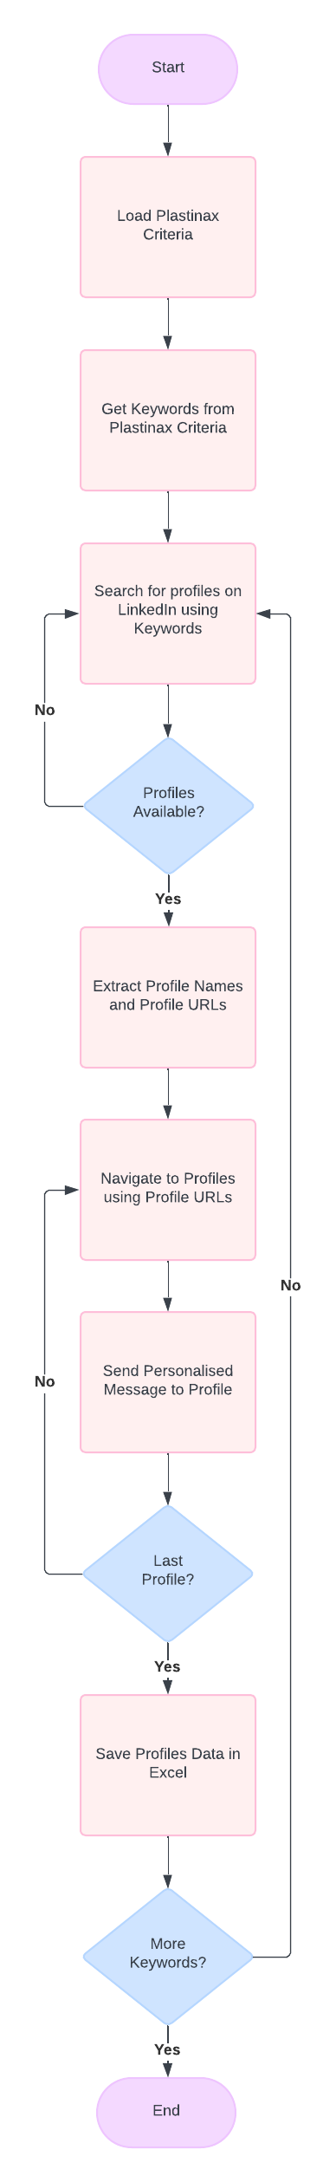
Figure 1: First Bot Flowchart

Second Bot - Retrieve Resumes from Emails and Analyse Best Applicants

As is process
- HR manually checks email inbox for job-related emails, scanning for attachments like resumes or job applications.
- HR staff manually open and review each resume, extracting key details such as education, skills, and work experience.
- HR manually compares each candidate’s qualifications with the job description to assess their suitability for the role.
- If a resume is missing key information, HR manually sends follow-up emails to candidates requesting more details or clarification.
- HR scores candidates based on their match with the job description and ranks them for further review.
- HR manually selects candidates that meet a predefined threshold and compiles a list for further consideration.
- HR manually generates a report of the top candidates and forwards this information to the hiring manager or the next step in the recruitment process.

To-be process
- The bot automatically scans emails for keywords like "job," "resume," or "recruitment," and checks for attached documents (PDFs).
- The bot extracts relevant information from attached resumes in PDFs using Optical Character Recognition (OCR) for image-based resumes.
- The bot is pre-fed with the job description, allowing it to evaluate the resumes based on the required skills, qualifications, and other criteria.
- The bot compares the parsed resumes data against the job description data and determine whether the candidate is a strong, possible or not a match.
- The bot categorizes candidates by job role in a database, which can be referenced for future job openings.
- The bot generates a list of candidates that are possible match and applicable in an Excel report and those that are not applicable are stored in another report and sends this to the HR team for further review and decision-making.

Second Bot – Flowchart
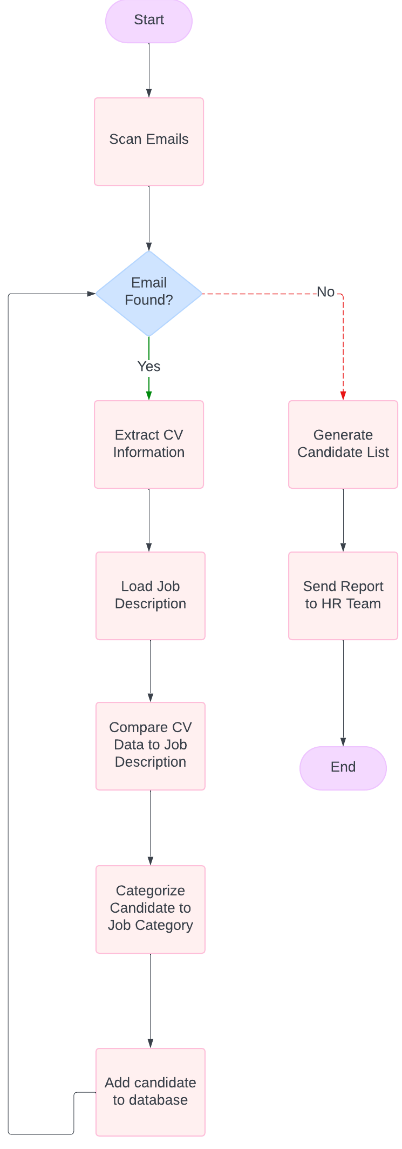
Figure 2: Second Bot Flowchart

Third Bot - Send Emails to Selected Applicants and Schedule Interviews

As is process
- HR manually reviews CVs and shortlists potential candidates.
- HR drafts and sends personalized interview invitations.
- HR checks interviewer availability and proposes time slots to candidates.
- HR manually updates the interview schedule based on candidate preferences.
- HR sends confirmation emails and sets up manual reminders for candidates and interviewers.
- HR coordinates cancellations or rescheduling requests manually.
- HR follows up with candidates who are unresponsive to invitations.
- HR manually sends rejection emails to non-shortlisted candidates.
- HR tracks all candidate statuses manually in an Excel sheet.

To-be process
- Bot automatically extracts CV data and shortlists potential candidates.
- Bot generates and sends personalized interview invitations via email.
- Bot checks interviewer availability and proposes time slots to candidates.
- Bot updates the interview schedule in Excel automatically based on candidate responses.
- Bot sends confirmation emails and sets up automated reminders for candidates and interviewers.
- Bot handles cancellations or rescheduling requests by updating schedules and sending revised invitations.
- Bot tracks candidate responses and follows up with unresponsive candidates automatically.
- Bot generates and sends rejection emails to non-shortlisted candidates based on predefined templates.
- Bot updates and tracks candidate statuses in real-time in the Excel sheet.

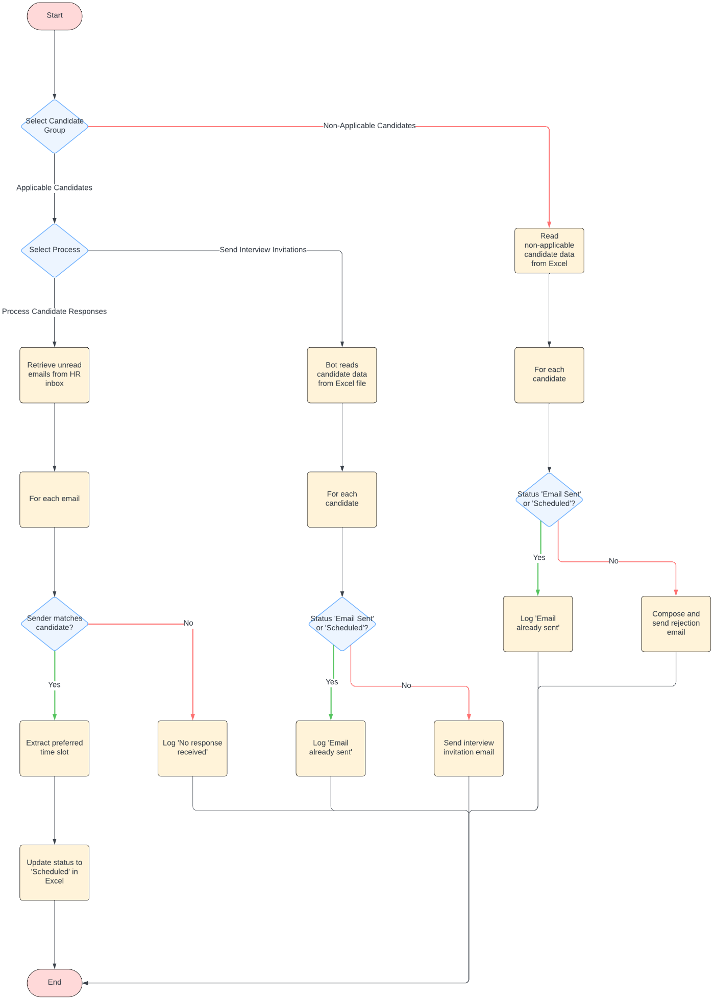
Third Bot – Flowchart
Figure 3: Third Bot Flowchart

Implementation

First Bot
The first bot process starts by asking the user to select a Job Description in PDF format from Files. Then, using Read PDF Text activity, the text from the job description is saved in a variable pdfText that will be used afterwards.
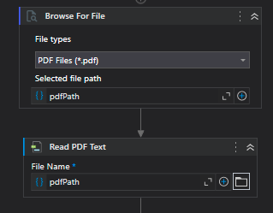
Figure 4: Get PDF File & Text
After the text from the PDF has been extracted, the bot read a text file where a prompt is saved. This prompt will be used to ask Google Gemini to extract Job Titles from the job description. Gemini will return a response in JSON format containing the possible job titles identified in this format (e.g., Software Developer, Software Engineer, Junior Developer, etc.)
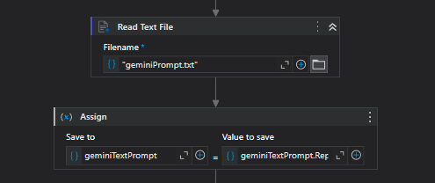
Figure 5: Gemini Prompt Text File

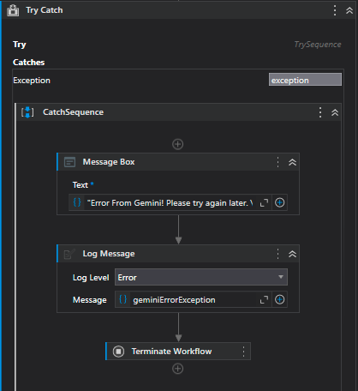
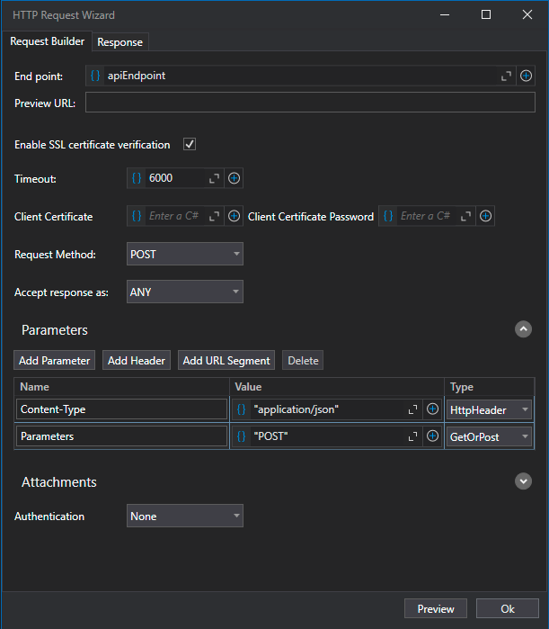
A Try-Catch Activity is wrapped around a HTTP Request activity to ensure a good execution of the API Call to Gemini. As it can be seen in the picture below, in the Try part of the Try-Catch, the API Call wait for a response and if the responseCode is not equals 200 (“OK”), an exception is thrown using the Throw activity. In the Catch part of the Try-Catch, a Message Box is used to tell the user that an error occurred and then the Workflow is terminated.
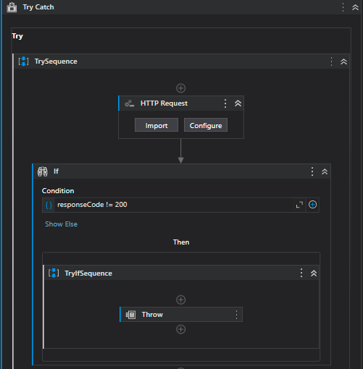

Figure 6: Gemini API Call

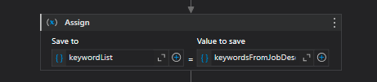
If the response code is 200(“OK”), the response content from the API Call is received in a JSON format. The Deserialize JSON activity is used to convert the JSON Response into string so as the bot can extract the required information. The Job Titles received by Gemini is saved into a string variable KeywordsFromJobDescription this format (e.g., Software Developer, Software Engineer, Junior Developer, etc.) which is broken down into individual keyword saved into an array of strings keywordList.
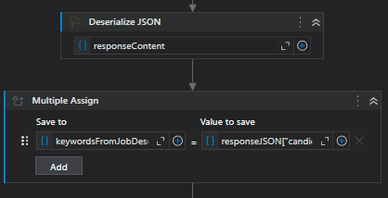
Figure 7: JSON Conversion & Keywords Extraction

An Open Browser activity is used to navigate to LinkedIn where for each keyword in the keywordList array, the bot passes the keyword in the search bar with “in Mauritius” at the end to search for possible candidates that may be fit the Job Description of Plastinax. The bot also filtered the search by People only.
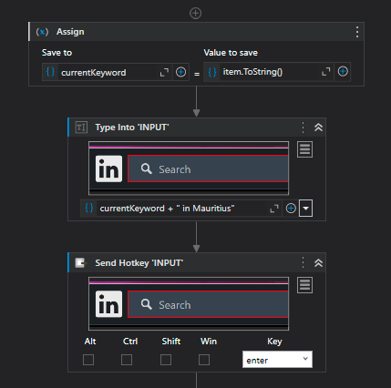
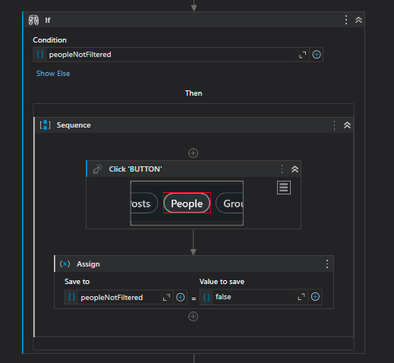
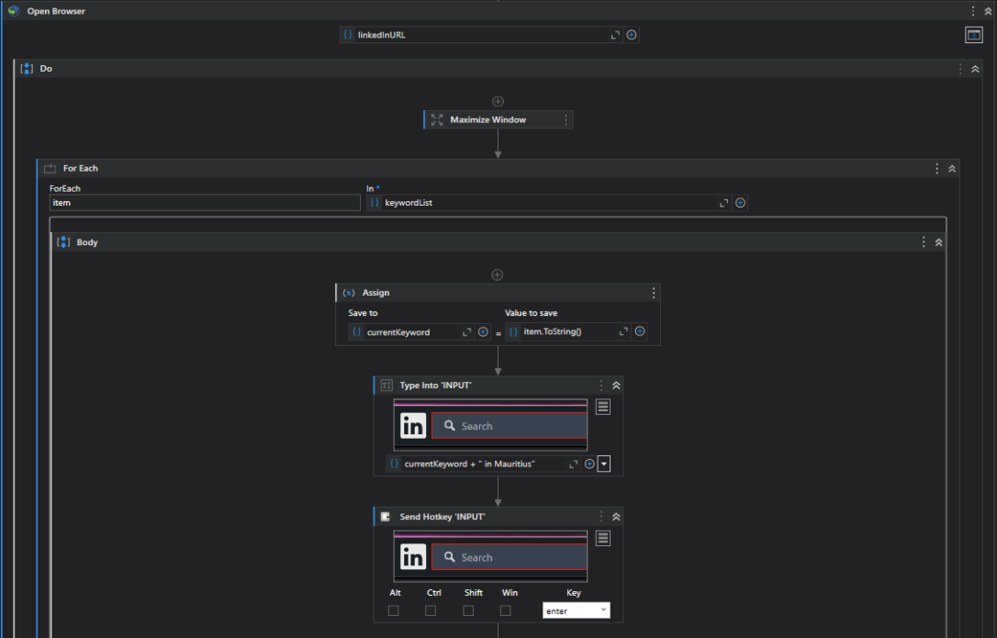

Figure 8: Candidate Search

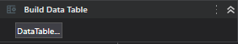
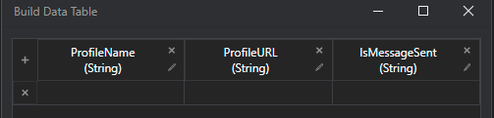
After the search, a DataTable, profileDataTable is built in the below structure to save the profiles data that will be scrapped by the bot.
Figure 9: Build DataTable

With this DataTable, the bot can now scrapped data from the search results page using the Data Scraping Feature in UiPath. The scrapped data is saved into the profileDataTable.
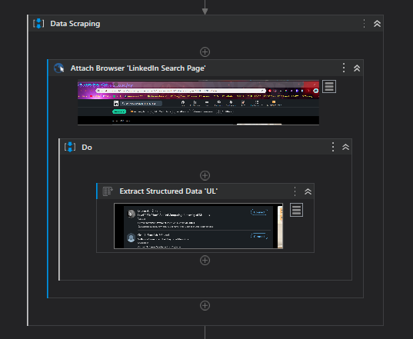
Figure 10: Data Scrapping

When the profile datas are scrapped, the bot uses the profiles URL to navigate to each profile to send them a personalised message.
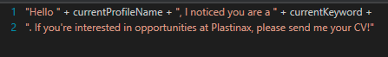
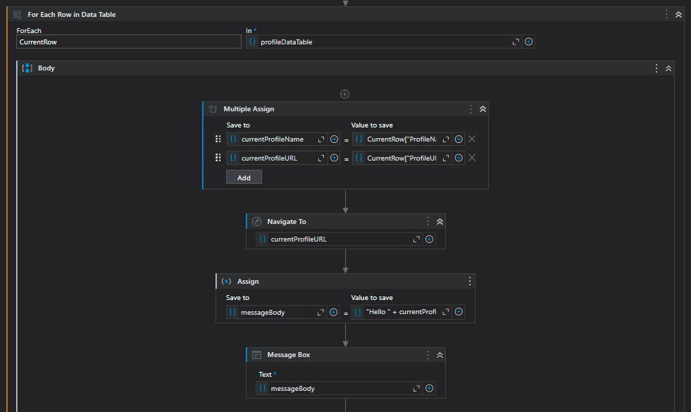
Figure 11: Navigation to Profile Pages & Send Messages
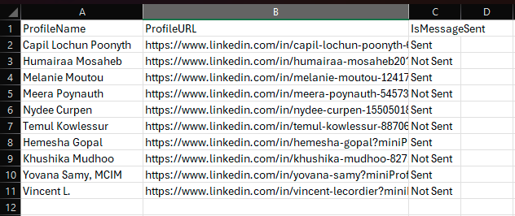
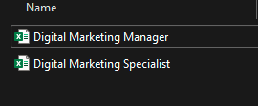
Then the profileDataTable is saved to different excels files (named based on the current Job Title) containing all the profileDataTable information for the current Job Title.
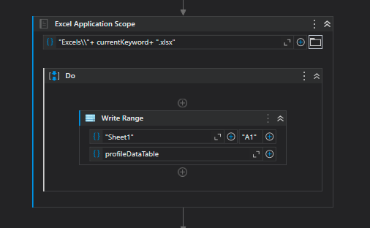

Figure 12:Save to Excel Files

Second Bot
The process of the second bot starts by fetching all unread emails from Outlook in the inbox folder. It then filters all emails that does not have an PDF attached to it and does not contain specific keywords such as CV, Resume, Application, etc. If no emails remain after the filtering, the whole process stops.
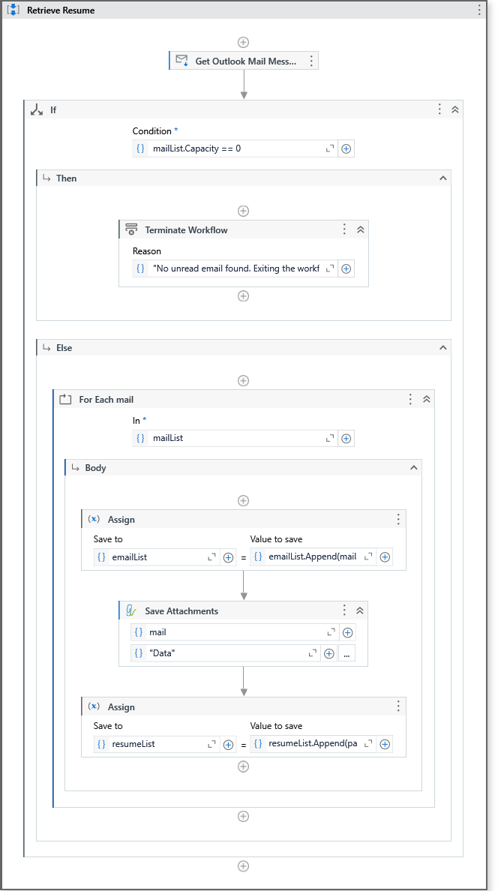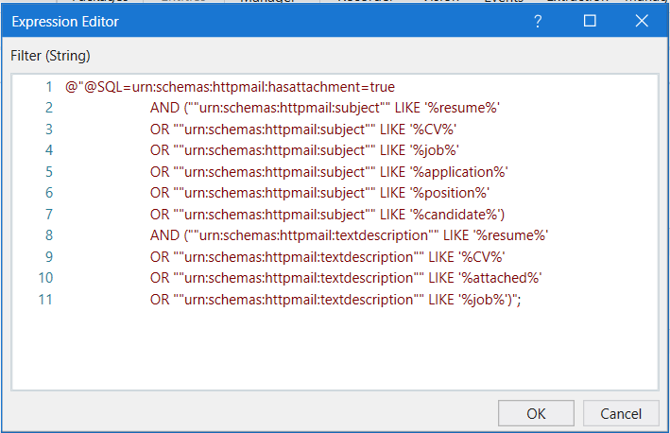
Figure 13: Get Filtered Emails
Otherwise, the attachment in each email is saved to a folder Data and their path is appended to a list.
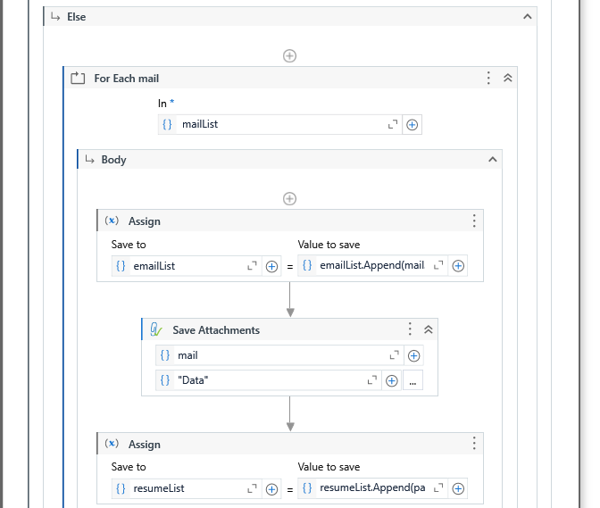
Figure 14: Save each resume from email
The job description is then loaded, and its contents is extracted using the UiPath OCR and if there is an exception, an error message is displayed.
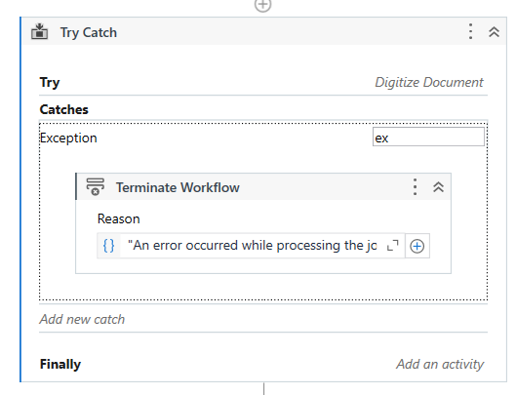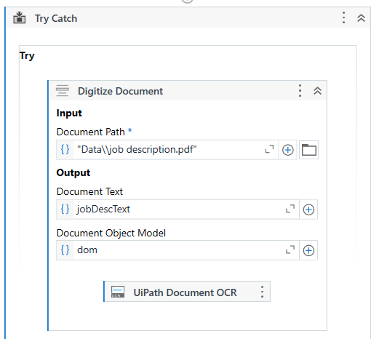
Figure 15: Extracting text from Job Description using OCR
Two Data Table, Applicable and Non-Applicable, is created to hold the table which needs to be saved in the excel. 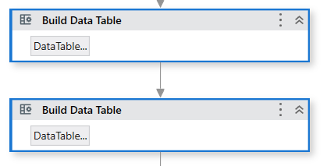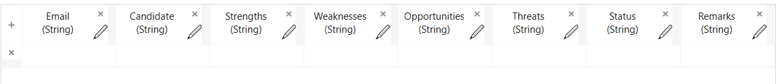
Figure 16: Building the Applicable and Non-Applicable DataTable
The data from each resume is extracted using the OCR.
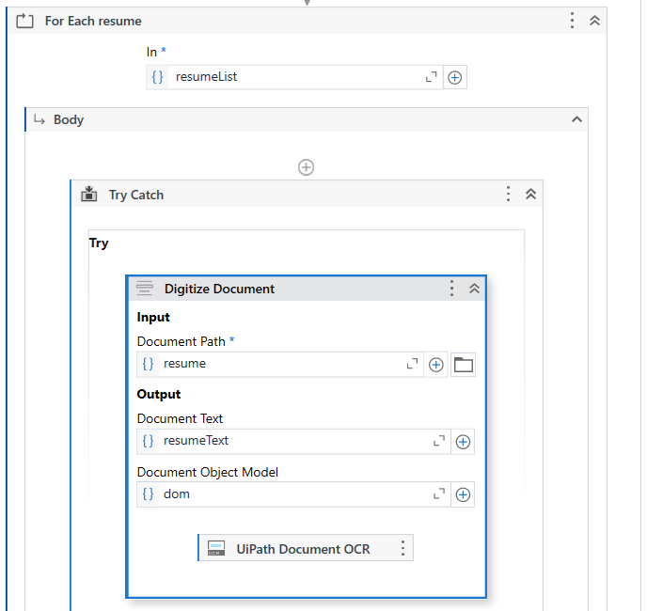
Figure 17: Extracting the text from the resume using OCR
A text file is then loaded which containing the prompt template which will be used by the LLM for the analysis. The job description and the resume text are load added to the prompt template which is then send to Gemini for analysis.
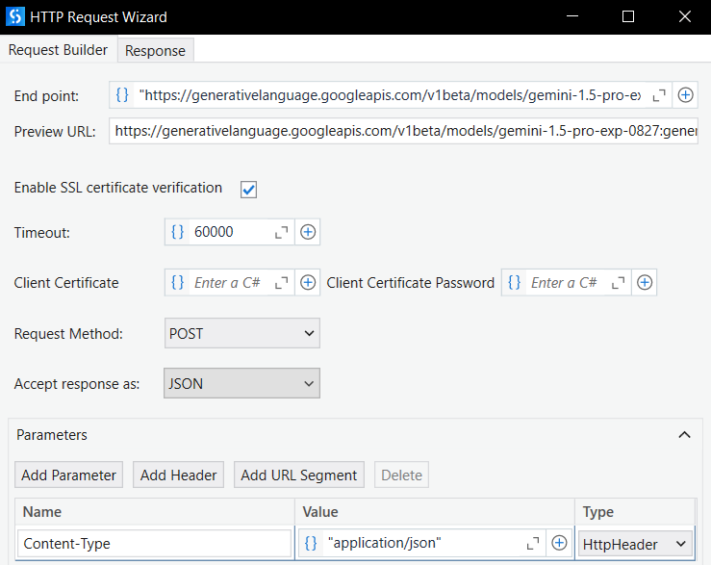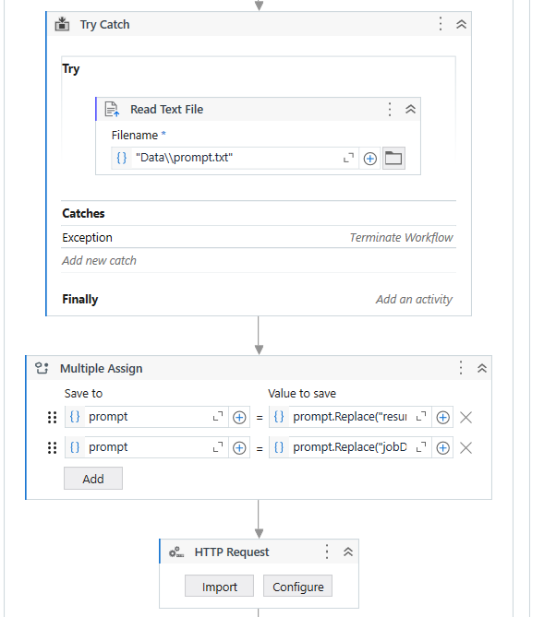
Figure 18: Loading and sending Correct prompt to LLM
If the response status from the LLM is not 200, the process is stopped as the LLM service is down. Otherwise, specific values from the JSON response are extracted and organized into a list in the correct order. If the resume_match field from the LLM determines that the resume is not applicable, it is added to the "NonApplicable" DataTable. Otherwise, it is added to the "Applicable" DataTable.
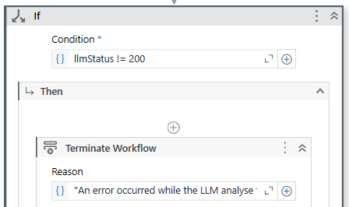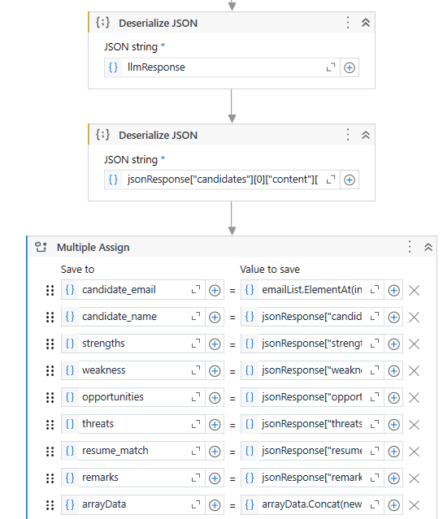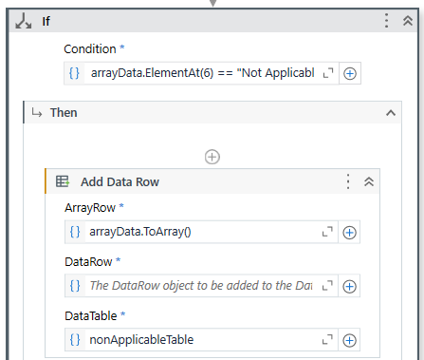
Figure 19: Extracting the response data to the corresponding DataTable
A python script is used to classify the resume into a job category which will be used when saving the data to a firebase. Another method is executed to get a token access to be able to access Firebase services.
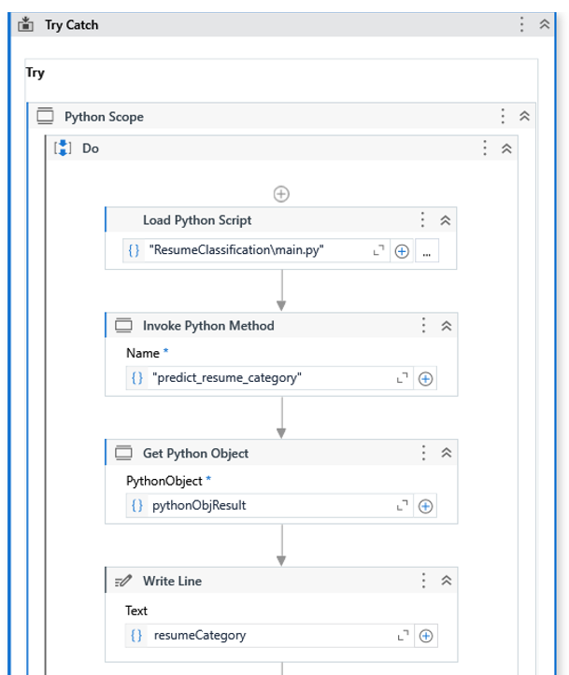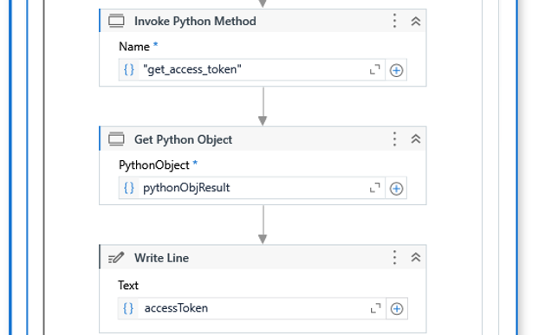
Figure 20: Classifying Resume and getting access token
The candidate information is then sent to Firebase using an HTTP request. If the data could not be sent to the Firebase, a log message is displayed to inform the user.
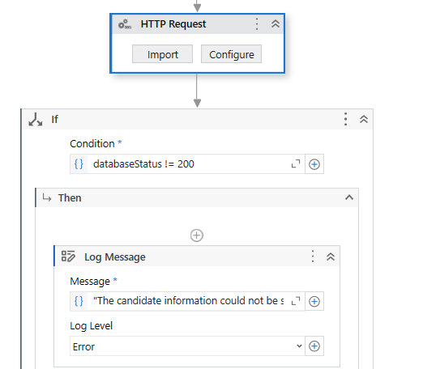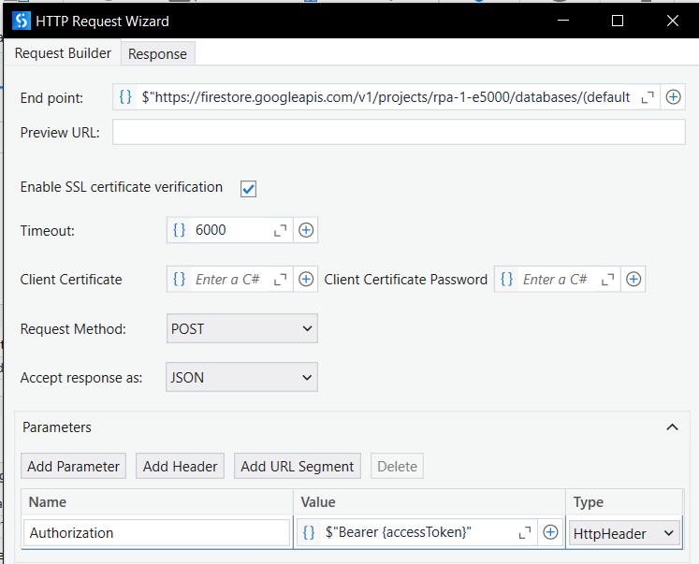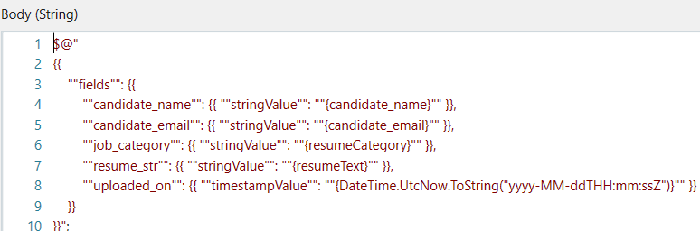
Figure 21: Sending the relevant fields to Firebase
Lastly the two DataTable are then saved in two different Excel reports. One for Non Applicable and another Applicable candidate. These two reports are attached to a custom email and is send to the HR Team.
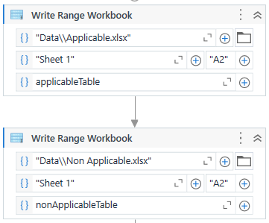
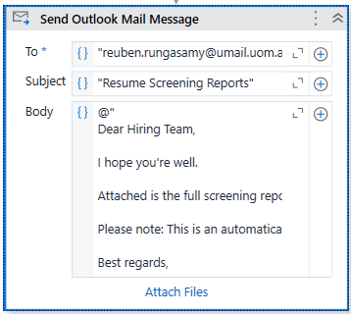
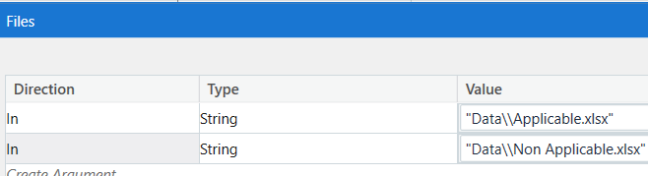
Figure 22: Exporting and Sending the Excel to HR Team

Third Bot
Candidate Group Selection(Applicable and Non-Applicable)
The process begins by prompting the user to select the candidate group to process. The input dialog provides two options:
- Applicable Candidates (those receiving interview invitations)
- Non-Applicable Candidates (those receiving rejection emails).
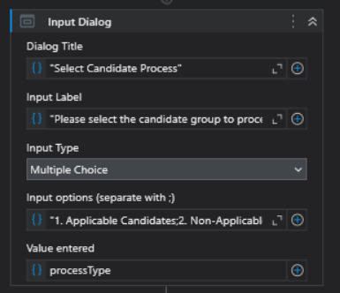
Figure 23: Select candidate group

Applicable Workflow
Step 1: Prompting to Select Applicable Workflow Process
The workflow begins by prompting the user to select which applicable process to run. The options are either to send interview invitations or process candidate responses. This step displays an input dialog box prompting the user to select either "Send Interview Invitations" or "Process Candidate Responses.". The result is stored in the variable applicableProcessType, which determines the next steps.
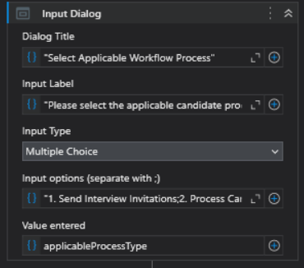
Figure 24: Select send or process mail

Step 2: Reading Candidate Data from Excel
Once the process type is selected, the bot reads candidate information from the Excel file using the Excel Read Range activity. The bot reads the data from the Excel file and stores it in a DataTable variable named CandidateData. The data includes information like the candidate's name, email, and status. The sheet used is "Sheet1," and the headers are included.
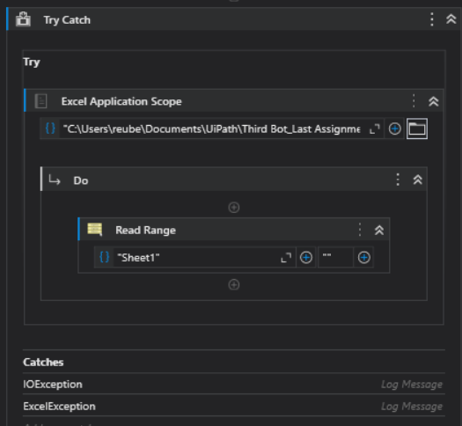
Figure 25: Reading Excel for Applicable Candidates
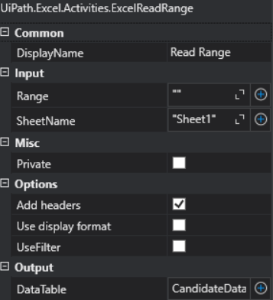

Step 3: Sending Interview Invitations
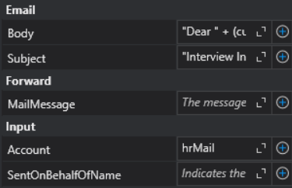
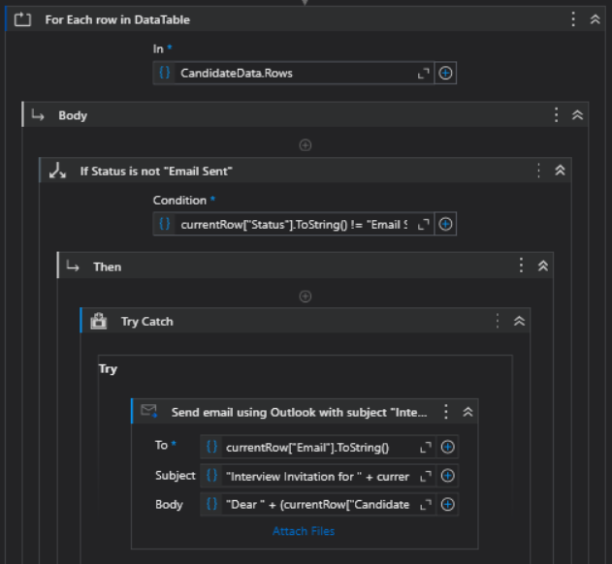
The bot loops through each row in the CandidateData table and sends personalized interview invitations using the Send Outlook Mail activity. The bot loops through the rows of the CandidateData table. For each candidate who hasn’t been marked as "Email Sent," the bot sends a personalized interview invitation. The SendOutlookMail activity uses dynamic values for the email address, subject, and body, where [Candidate Name] is extracted from the currentRow variable.

Figure 26: Send Interview Invite
Step 4: Updating the Status of Candidates
After successfully sending an interview invitation, the bot updates the Excel sheet to mark that the email has been sent by writing "Email Sent" in the corresponding row using the Excel Write Cell activity. The bot writes "Email Sent" in the Status column for the respective candidate to indicate that the invitation has been sent. The ExcelWriteCell activity targets the appropriate cell based on the current row index.
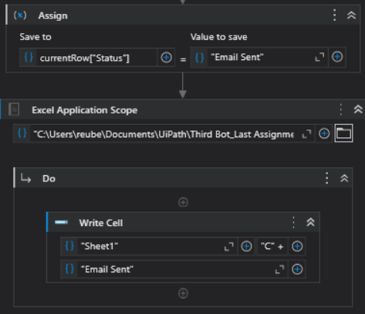
Figure 27: Update status in excel

Step 5: Retrieving Candidate Emails
The bot retrieves unread emails from the Outlook inbox using the GetOutlookMailMessages activity. It retrieves the most recent unread messages and stores them in the mailMessages list variable for further processing. This step ensures that only new responses are processed.
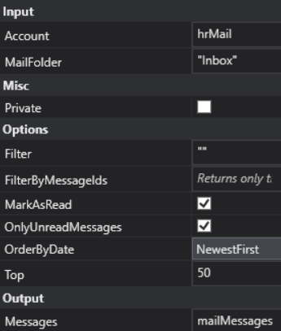
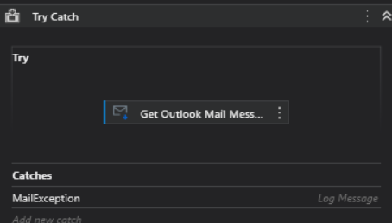

Figure 28: Retrieve Candidate Response from inbox

Step 6: Looping Through Emails and Reading Candidate Data
The bot loops through each email message in the mailMessages list using the For Each activity. Simultaneously, it reads the candidate information from the Excel file using the ExcelReadRange activity, storing the data in the CandidateData DataTable. This table includes candidate names, email addresses, and statuses, which the bot uses to cross-reference and match the email sender’s address with the appropriate candidate. This ensures that the bot processes the correct candidate's response efficiently.
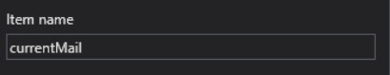
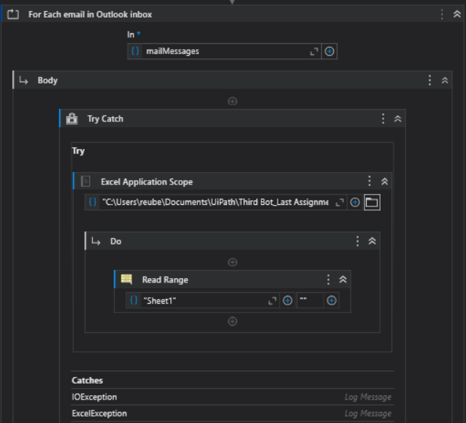

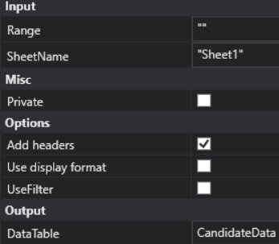

Figure 29: Reading the candidates responses
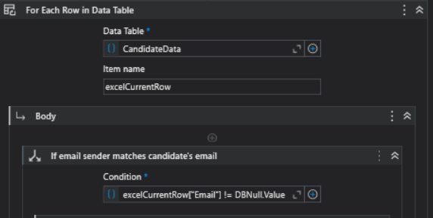
Step 9: Matching Email Sender to Candidate
For each email, the bot compares the sender's email address with the email addresses stored in the CandidateData table. If the sender's email matches a candidate's email in the table, the bot identifies this as the response from that specific candidate. If no match is found, the bot logs the absence of a response for that candidate and continues processing the remaining emails.
Figure 30: Store in datatable based on matching email

Step 10: Extracting and Updating Preferred Time Slot and Status
Once a match is found between the email sender and a candidate, the bot parses the email body using a regular expression to extract the candidate's preferred interview time slot. This time slot is stored in the variable currentRow__PreferredTimeSlot_. The bot then updates the candidate's status to "Scheduled" and writes both the status and the preferred time slot to the corresponding row in the Excel sheet using the ExcelWriteCell activity. This ensures that the candidate's details are accurately updated in both the "Status" and "Time Slot" columns.
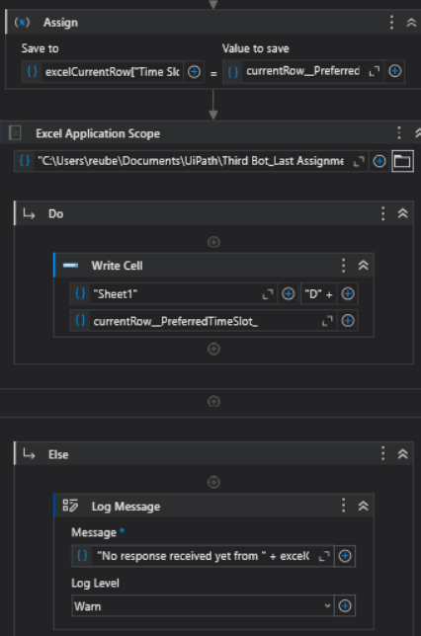
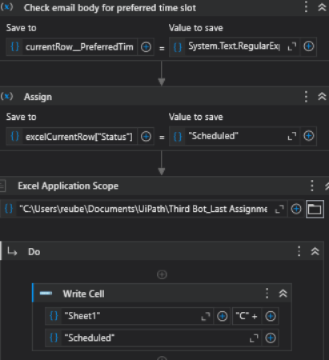

Figure 31: Retrieving the time slot and updating status and time slot in excel
Step 11: Error Handling
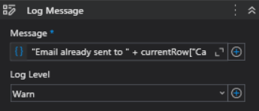
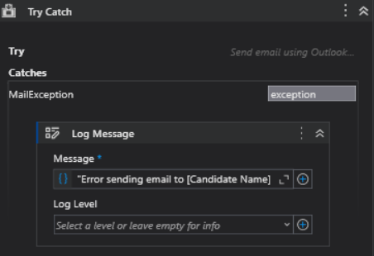
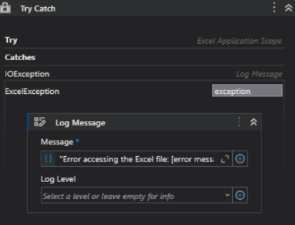
Error handling is incorporated using Try-Catch activities to ensure the bot logs any issues and continues processing other candidates. For instance, if an error occurs during the SendOutlookMail activity (such as invalid email addresses or Outlook issues), the exception is caught, and a Log Message records the error, including the candidate's name. Similarly, when reading or writing to Excel, any file access errors are captured and logged. This ensures that even if an issue arises, the bot continues processing the remaining candidates without disruption.

Figure 32: Error handling for Applicable workflow

Non-Applicable Workflow
Step 1: Reading Non-Applicable Candidate Data from Excel
The bot starts by reading the non-applicable candidates' data from an Excel file named "Non Applicable.xlsx" using the ExcelReadRange activity. The data, stored in a NonApplicableCandidateData DataTable, includes details like candidate names, email addresses, and specific remarks about their application. The bot retrieves data from "Sheet1," ensuring that headers are included.
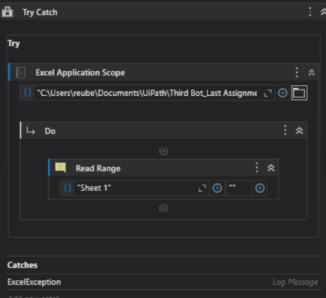

Figure 33: Reading Excel for Non-Applicable Candidates

Step 2: Looping Through Non-Applicable Candidates
The bot loops through each candidate row in the NonApplicableCandidateData table using the For Each activity. For each candidate, it checks the "Status" column to determine if a rejection email has already been sent.
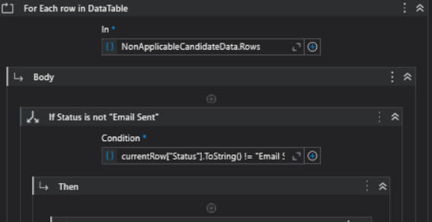
Figure 34: Check if email has already been sent

Step 3: Composing a Customized Rejection Email Using Gemini
For candidates who have not yet received a rejection email (i.e., those with a status other than "Email Sent" or "Scheduled"), the bot generates a customized rejection email based on their individual remarks. To achieve this:
- The bot formulates the email content by combining a polite message with the specific rejection remarks found in the "Remarks" column of the current candidate row.
- The bot sends an HTTP request to the Gemini API using the HttpClient activity, passing the email content template, along with the remarks, to generate a professional and personalized email. The HTTP request sends a JSON object containing the email template and candidate-specific data.
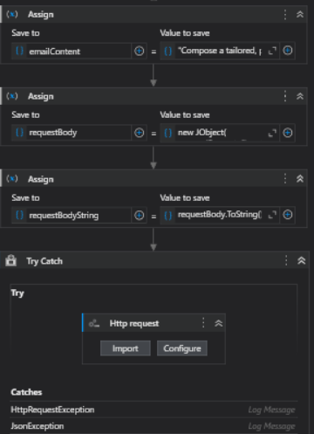
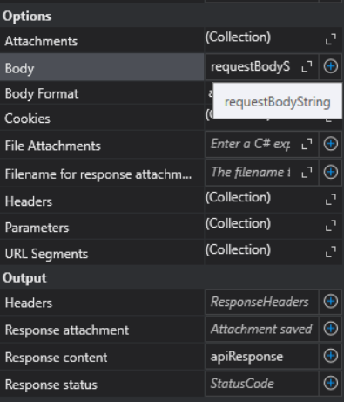

Figure 35: Customized email based on remarks using Gemini

Step 4: Sending the Personalized Rejection Email and Updating Status
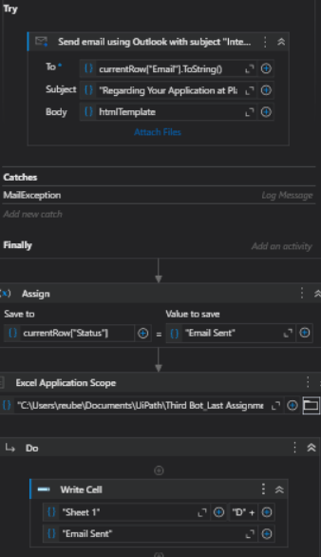
After receiving the customized rejection email from the Gemini API, the bot sends it using SendOutlookMail with the candidate's name and rejection message. The subject is set professionally, and after sending, the bot updates the candidate's status to "Email Sent" in the Excel sheet to avoid duplicate emails. If the status is already "Email Sent," the bot logs this and skips to the next candidate.

Figure 36: Sending email and updating Status in excel
Step 5: Error Handling
Error handling is integrated throughout the workflow using Try-Catch blocks. If an issue occurs while reading the Excel file (e.g., ExcelException), accessing the Gemini API (e.g., HttpRequestException or JsonException), or sending emails (e.g., MailException), the bot logs the error and continues processing other candidates. This ensures that the workflow is not disrupted by individual errors, maintaining smooth operation for all remaining candidates.
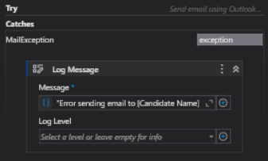
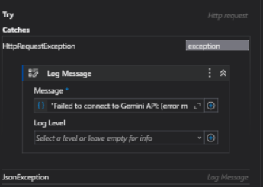
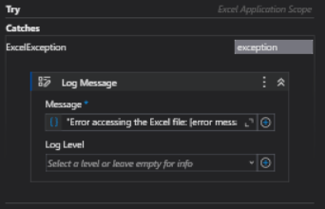
Figure 37: Error handling for Non-Applicable workflow

Conclusion

